Spring 2025
Cse-5392 wireless Communications
the university of texas at arlington


lab 1 report
Submitted toward the partial completion of the requirements for CSE 5392
Under the guidance of
Prof. Jason Losh
By:
Dario Ugalde, 1001268068

Introduction
The first lab of this course aims to introduce basic techniques used to modulate streams of binary data. This process serves as the foundation for transmitting wireless data. Completion of this lab provides practical experience in direct-digital synthesis (DDS) implementation, bpsk, qpsk, 8psk, 16qam modulation implementations, and root-raised cosine (RRC) filter implementation. The lab also provides instructions for the assembly of the circuit that will be used for rest of the semester. More details on these topics will be provided in the corresponding sections below.

Steps 1 – 4: Understanding IQ Sources
The lab begins with a demonstration of the generation of upper, lower, and double-sided modulation. This is achieved by using an arbitrary waveform generator connected to the RF signal generator. Using the in-phase (I) and quadrature (Q) signal components as variables allows for efficient control of the amplitude and phase of the desired carrier frequency. For this configuration, the carrier frequency was designated 27.1MHz. By applying modulation with the IQ components, we created upper, lower, and double-sided modulation bands as shown in the images below. These sidebands are important to us because they provide the means over which our data will be transported by providing the bandwidth.
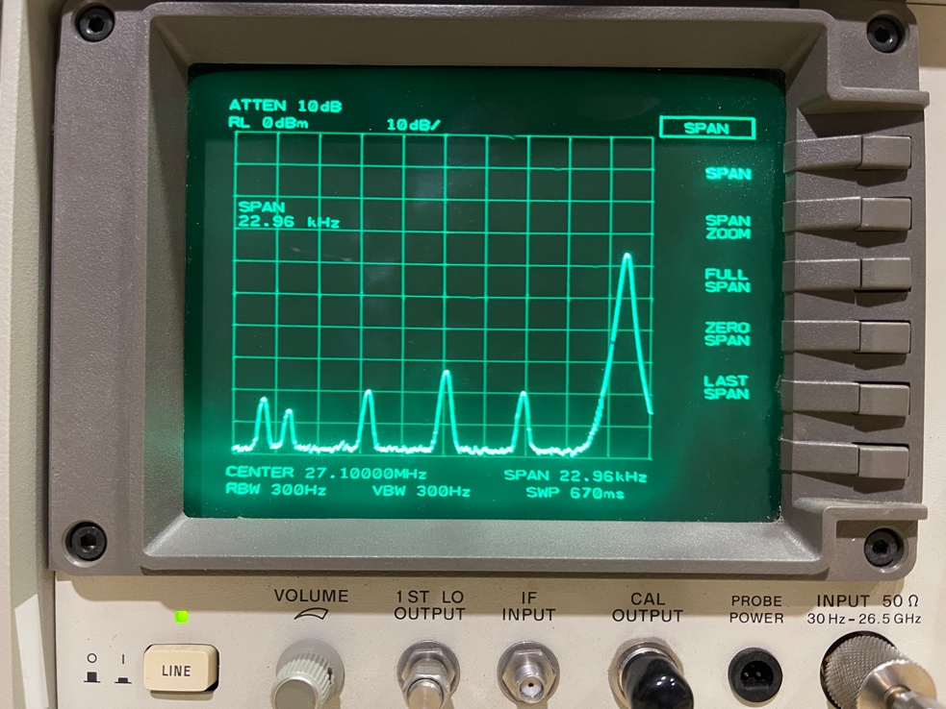
Figure 1. Spectrum capture of the lower side band channel
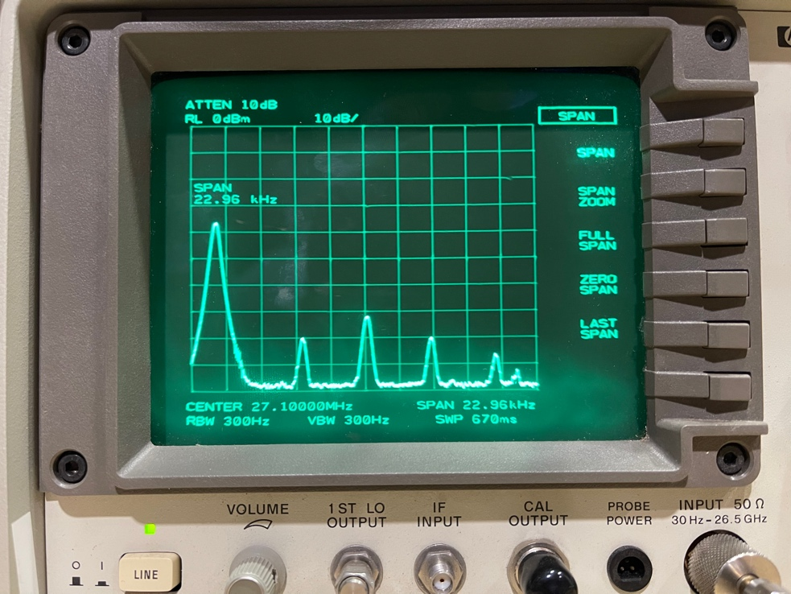
Figure 2. Spectrum capture of the upper side band channel
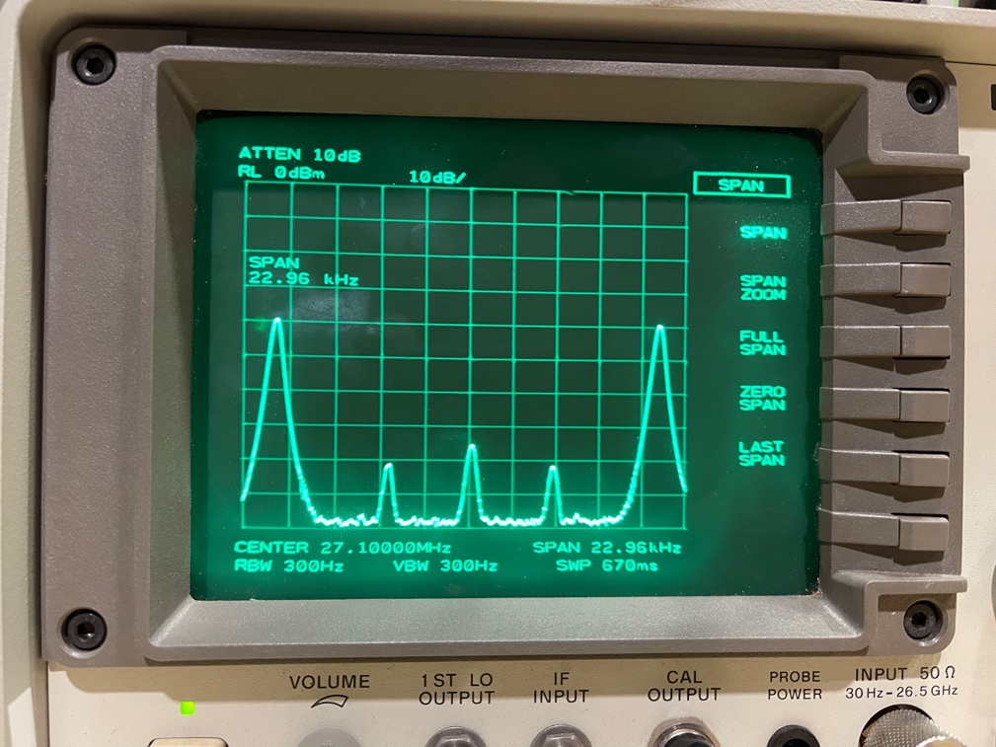
Figure 3. Spectrum capture of the double side band channels

Steps 5 – 6: Build the Dual DAC Circuit
Once the side band demonstration was completed, the lab called for the assembly of a dual digital-to-analog convert (DAC) circuit. When connected to the red board, this circuit enabled us to provide for our own arbitrary waveform generator. The circuit consisted of connecting an MCP4822 Dual DAC, TLC072 Dual Op Amps, and Max 660 charge pump. The schematic for this circuit was provided in the instructions of this lab. After connecting the components, software was written for the red boards to be able to control the DAC outputs
Our DAC control software consisted of using the existing SPI bus library to provide the interface to the DAC. The SPI bus was configured using the initSpi function with a pinMask of 1. The SPI baud was configured with a baud rate of 20,000,000 and a 1, 1 polarity and phase. The 16-bit message consisted of an upper 4-bit header to control DAC selection, gain, and power-down options and 12-bits for DC voltage selection on a range of 0V to 2.047V. This can be seen in use in our code’s writeSpi function.

Steps 7 – 12: Modulation Through Sinusoids
For the next steps of our lab the dual DAC outputs were connected through to the dual op amps and charge pump set to provide for a 2V to -2V output range. Additional control was implemented into the red board software to produce sine and cosine waveforms. In our software, this was achieved through the Enable_ DUAL_DAC_Isr, LOAD_SINE_LUT, and DUAL_DAC_Isr functions. Using a simple shell as the entry point, the “dac dual <amplitude> <frequency>” would call the enable function to configure the look-up table and calculate the required stepping offsets to produce a sinusoid through rapidly modifying the DC outputs through the user of the red board’s timer modules. Once implemented the XY mode of the oscilloscopes revealed a circle. We forgot to take a picture of the circle for this section.
Steps 9 – 12 were repeats of 1 – 4 using the red board/circuit outputs as the arbitrary waveform generator.

Steps 13 – 18: Unfiltered Symbol Streams
This portion of the lab focused on the implementation and visualization of the modulation techniques described in the introduction. In our software, we created 4 arrays to house the various points of each of these modulation techniques. These points were derrived based on the calibration values of our DAC outputs. These tables could then be used in conjuction with a given bitstream to modulate it, preparing it for transmission with our I and Q components.
BPSK modulation provides for 2 phases which represent 1 or 0 depending on a given bit. In our code, the I component of our table is the only value that changes from either the MAX calibration to the MIN calibration values. The Q component stays at 0. When a bit received for modulation the bit being 1 or 0 moves modulates between one of the these two states.
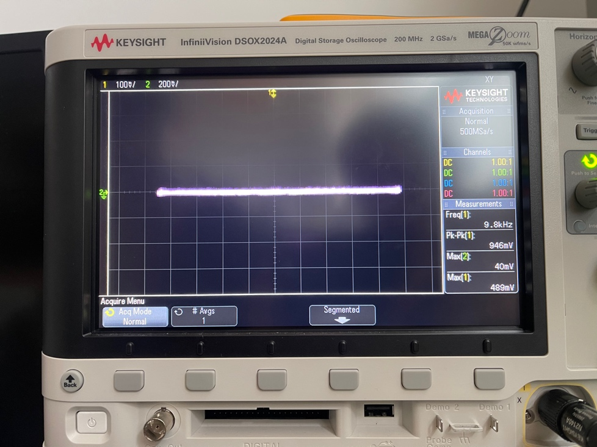
Figure 4. XY mode capture of the unfiltered BPSK constellation
QPSK adds allows use of another dimension in this frequency plane and extends the capabilities of BPSK to encode 1 additional bit at a time, now allowing for 2-bit modulation. Adding another bit requires 4 potential states to encompass all possible values of the incoming bits. As a result, this creates a square shape constellation as shown below. At the time the picture was taken below, there was an error in our circuit that resulted in reduced amplitude of one of the components resulting the in rectangle seen below. This was later corrected for our demo, but we forgot to take pictures of the corrected constellation.
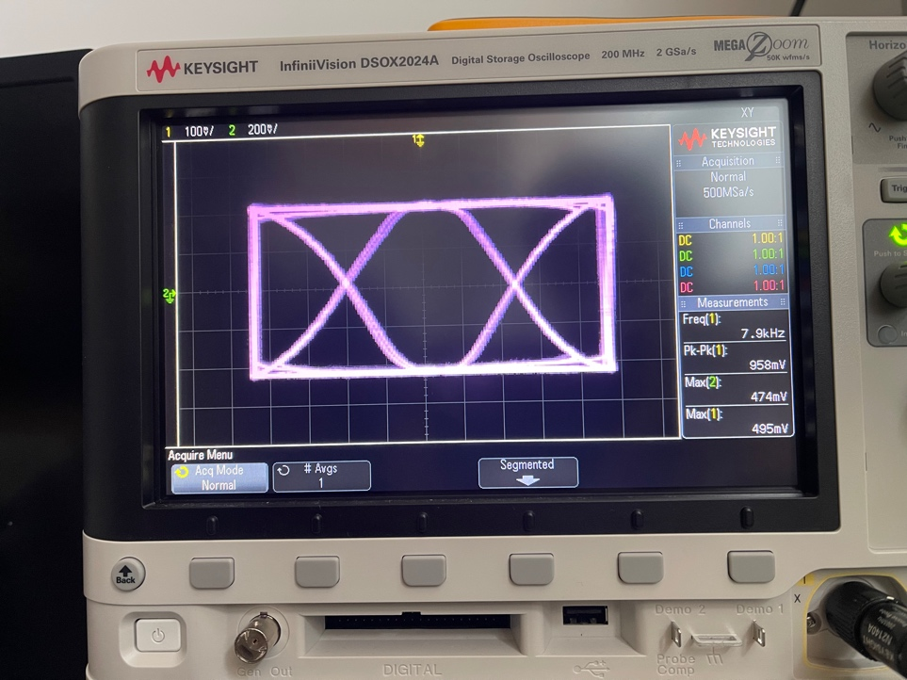
Figure 5. XY mode capture of the unfiltered QPSK constellation
8PSK and 16QAM follow the same premise as before and allow for 8 and 16 states respectively. Captures of those constellations are included below as well.
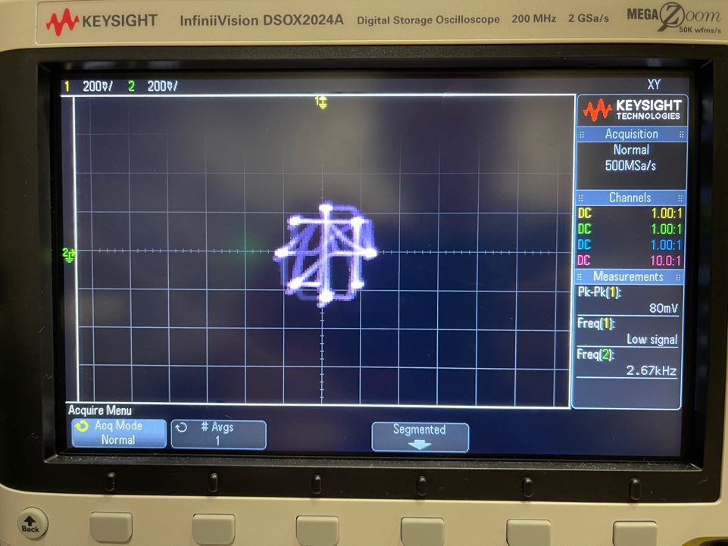
Figure 6. XY mode capture of the unfiltered 8PSK constellation

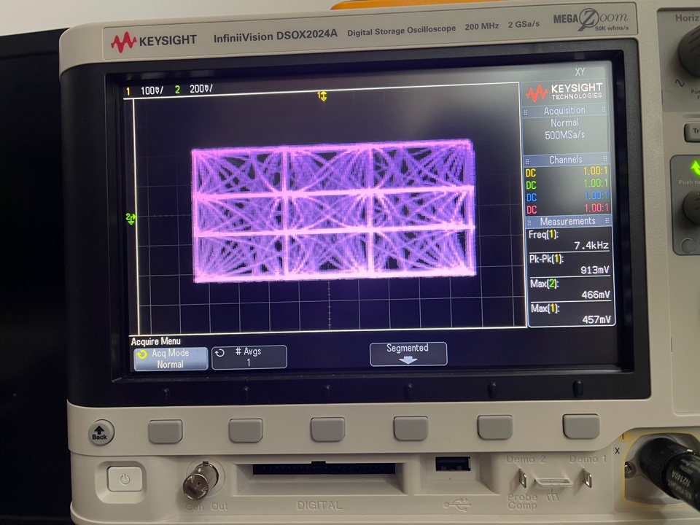
Figure 7. XY mode capture of the unfiltered 16QAM constellation

Steps 19 – 20: RRC Filtered Symbols
The final steps of the lab involved implementing the RRC filter on top of the modulated output values. In our code, we accomplished this by adding a check to the MOD_Isr function that would load the most recent I and Q values into an array and perform a convolution over the array with the given RRC coefficients. The following images depict through the spectrum analyzer how filter affects each of the modulation types.
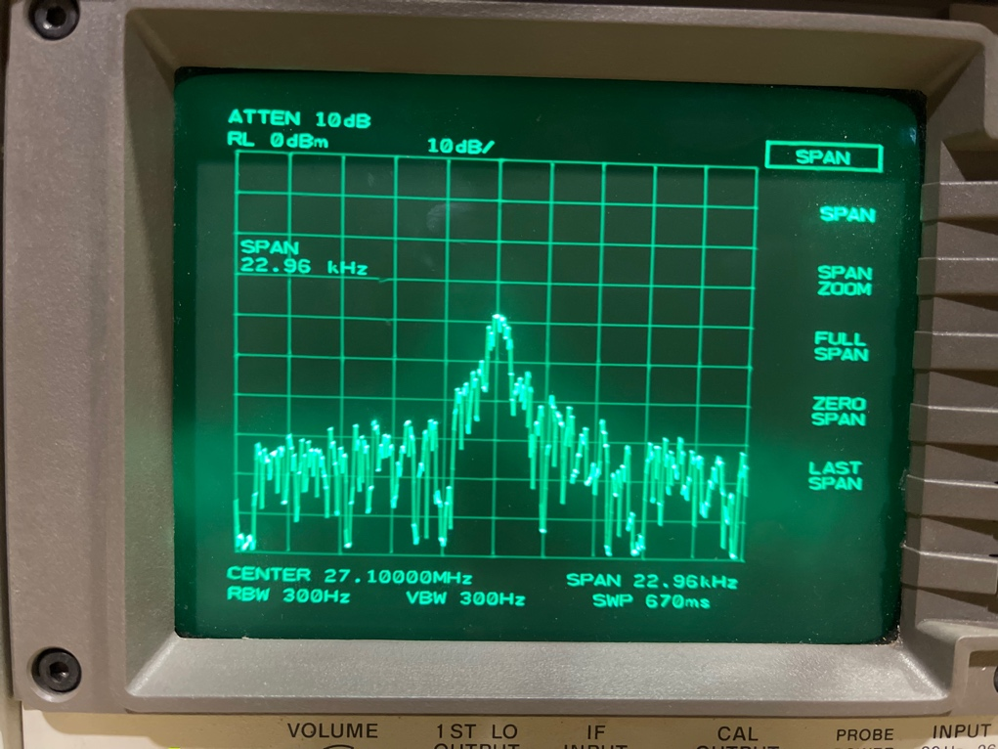
Figure 8. BPSK with filtering on spectrum analyzer
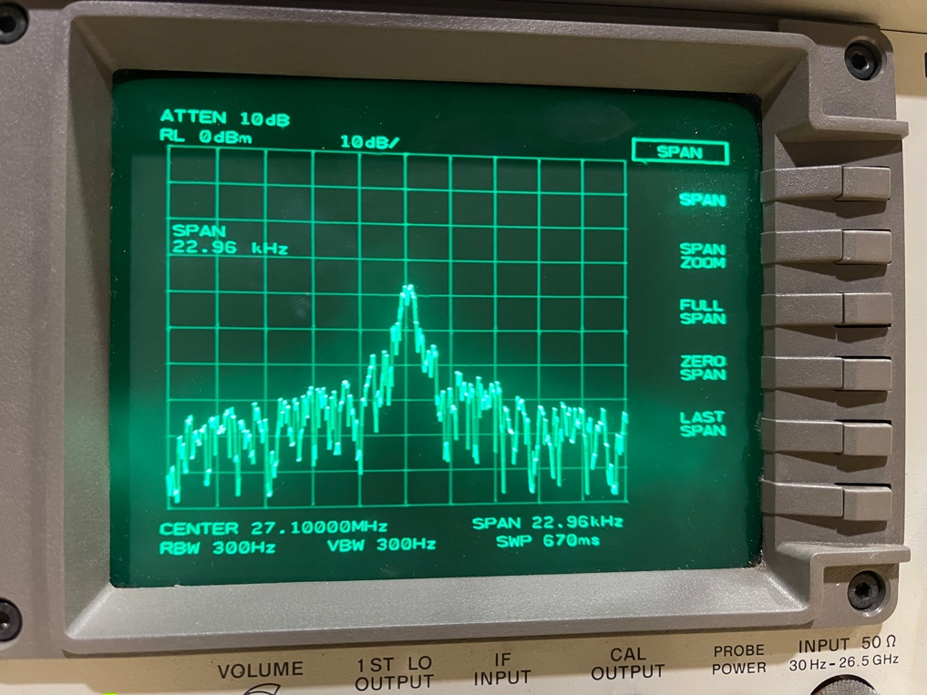
Figure 9. QPSK with filtering on spectrum analyzer
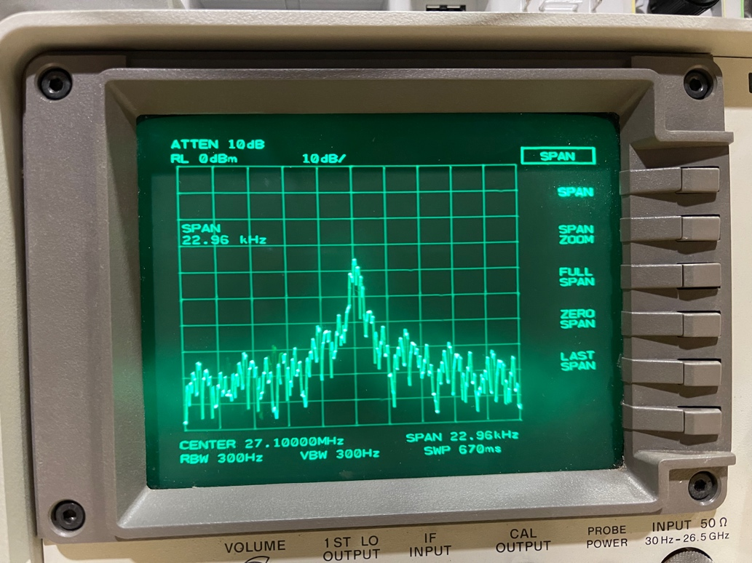
Figure 10. 8PSK with filtering on spectrum analyzer
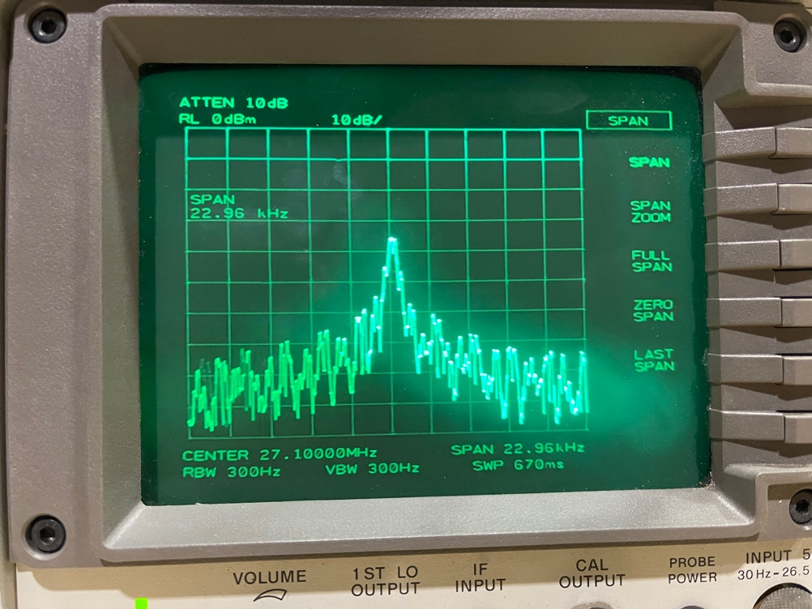
Figure 11. 16QAM with filtering on spectrum analyzer

Conclusion
As previously mentioned, this lab introduced simple modulation techniques from the ground up. By creating the I and Q components via sine and cosine we learned how to manipulate a carrier frequency’s side bands to load its bandwidth with data. From we then introduced the BPSK, QPSK, 8PSK, and 16QAM modulation techniques to provide the means of encoding data by modifying the carrier frequency with sideband channels. Further improving our use of the spectrum, we applied the RRC filter over our output stream. Applying this filter to our symbols reduces the likelihood of symbols producing interference for future symbols by ensuring a controlled transition from one set of symbols to another. Going forward the work done in this lab will serve as the foundation of the remaining work to be completed the rest of this semester.
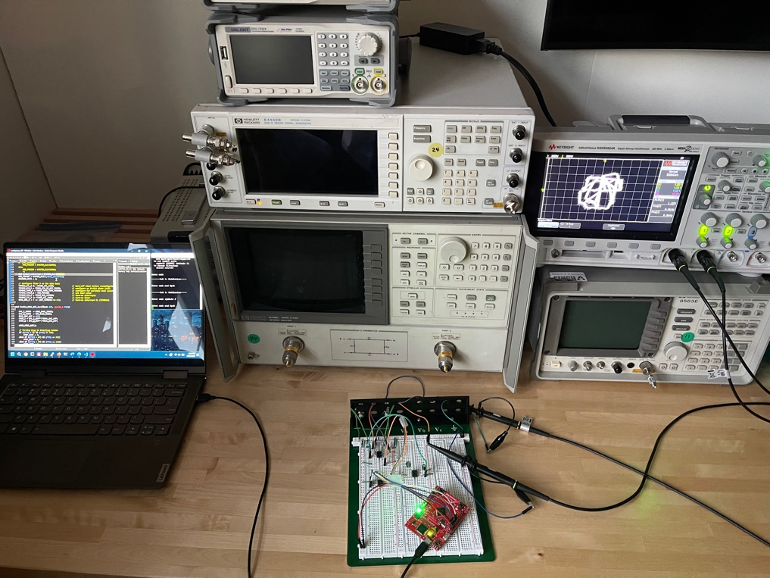
Figure 12. Image of the setup used to complete Lab 1
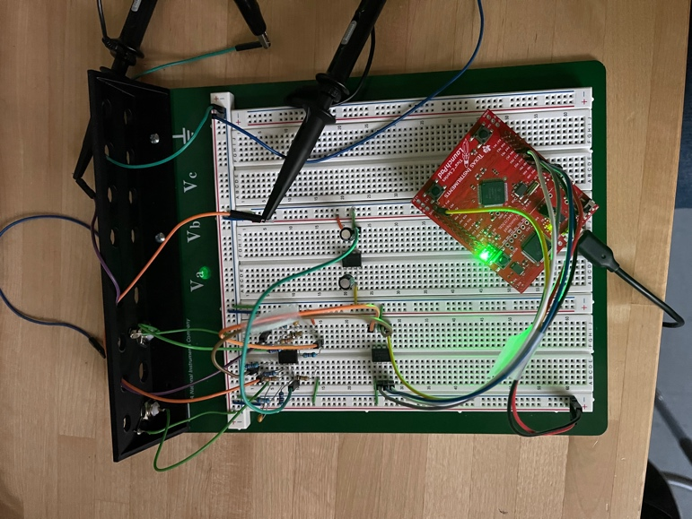
Figure 13. Close up of the constructed circuit

